- Create user with name Techie and provide sudo access to user.

Objective
To create a new user account named Techie and grant the user administrative (sudo) privileges so they can execute commands requiring elevated permissions.

Purpose
The purpose of this task is to provide a separate user account with secure administrative access instead of using the root account directly. This improves system security, accountability, and user management.

Implementation
- Create a new user named Techie using the useradd command with a home directory.
- Set a password for the user using the passwd command.
- Add the user to the sudo group (Ubuntu/Debian) or the wheel group (RHEL/CentOS/Fedora) using the usermod command.
- Verify the user's group membership and confirm sudo access by executing a command such as sudo whoami.

Conclusion
The user Techie was successfully created and granted administrative (sudo) privileges. The user can now perform system administration tasks securely using sudo, reducing the need to log in as the root user while maintaining proper access control and accountability.
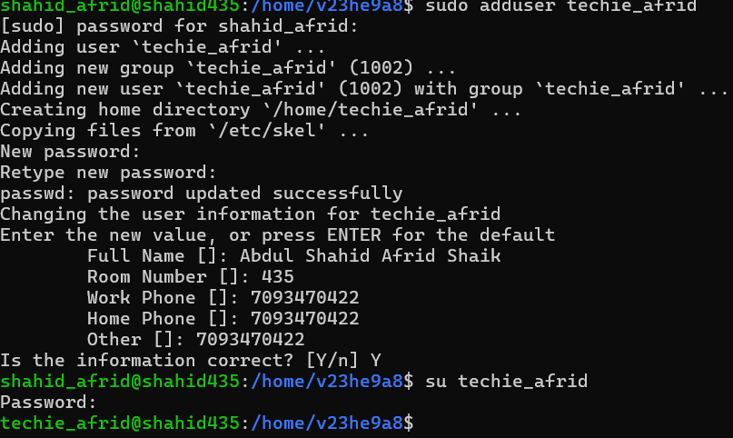
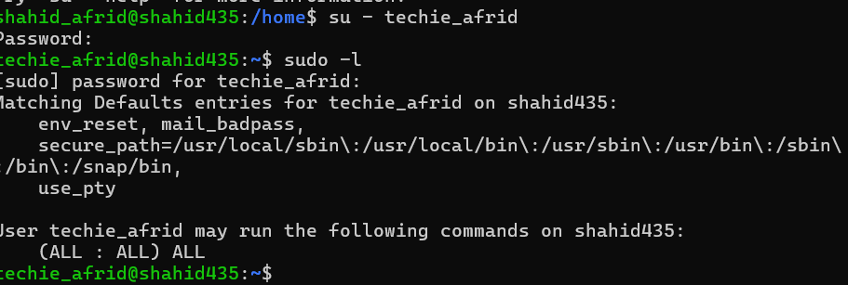

- Navigate to the home directory.
Objective:
To navigate to the home directory of the user and access the default workspace for managing personal files and directories.
Purpose:
The purpose of this task is to access the user's personal workspace, where user-specific files, folders, and configuration settings are stored for everyday use.
Implementation:
The home directory was accessed by using the cd command (or cd ~). The current working directory was then verified using the pwd command to confirm that the user had successfully navigated to the home directory.
Conclusion:
The home directory was successfully accessed, and its location was verified. This provides the user with the appropriate workspace for performing file management and other system administration tasks.

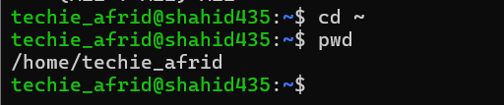

- Create a new directory.
Objective:
To create a new directory for organizing files and storing data in a structured manner.
Purpose:
The purpose of creating a new directory is to organize files efficiently, improve file management, and maintain a clear directory structure within the file system.
Implementation:
A new directory was created using the mkdir command by specifying the desired directory name. After creation, the directory was verified to ensure it had been successfully added to the current location.
Conclusion:
The new directory was successfully created, providing a dedicated location for storing and organizing files, which helps maintain a well-structured and manageable file system.
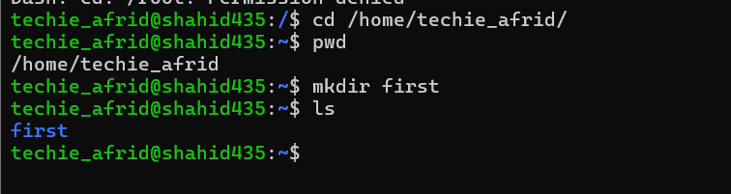

- List the contents of a directory.
Objective:
To display the contents of a directory and view the files and subdirectories it contains.
Purpose:
The purpose of listing directory contents is to identify available files and folders, verify the existence of specific items, and manage the file system effectively.
Implementation:
The contents of the directory were displayed using the ls command. The output was examined to view all files and subdirectories present in the specified location.
Conclusion:
The directory contents were successfully listed, allowing the user to verify and manage the available files and folders within the directory.

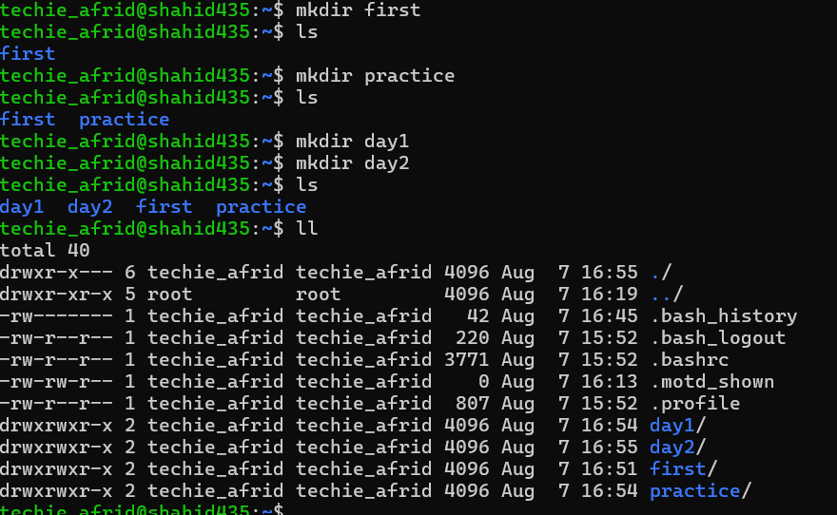
- Change the current directory.
Objective:
To change the current working directory to a different location in the Linux file system.
Purpose:
The purpose of changing the current directory is to access different locations in the file system for performing file and directory management tasks.
Implementation:
The current working directory was changed using the cd command followed by the desired directory path. The new location was then verified using the pwd command to ensure that the directory change was successful.
Conclusion:
The current working directory was successfully changed, allowing access to the required location for carrying out file management and other system operations.
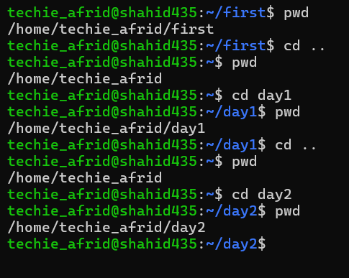

- Create a new empty file.
Objective:
To create a new empty file in the current directory.
Purpose:
The purpose of creating an empty file is to prepare a file for storing data, scripts, or configuration information without adding any initial content.
Implementation:
A new empty file was created using the touch command followed by the desired file name. The file was then verified to ensure it had been created successfully in the current directory.
Conclusion:
The empty file was successfully created and is now available for storing data or editing as required.
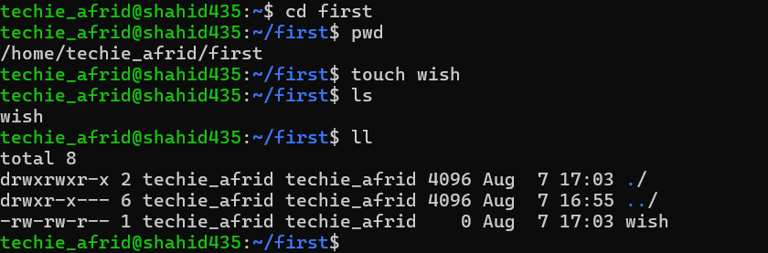

- View the contents of a file.
Objective:
To display the contents of a file stored in the Linux file system.
Purpose:
The purpose of viewing a file is to read and verify its contents without making any modifications, which is useful for checking data and configuration files.
Implementation:
The contents of the file were displayed using the cat command followed by the file name. The output was examined in the terminal to verify the information stored in the file.
Conclusion:
The file contents were successfully displayed, allowing the user to read and verify the stored information.
Using cat

Using head
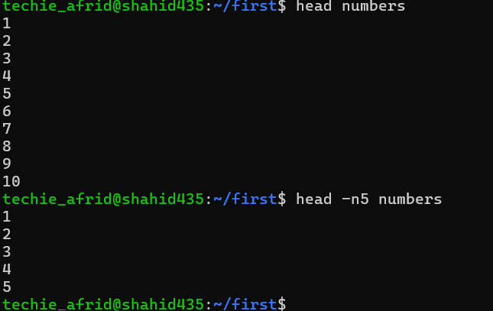
Using tail
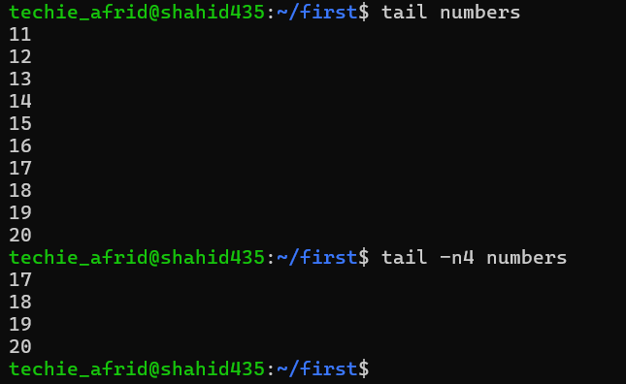

- Copy a file to another location.
Objective:
To create a duplicate copy of a file and store it in another location within the file system.
Purpose:
The purpose of copying a file is to create backups, transfer files between directories, and maintain multiple copies of important data.
Implementation:
A file was copied to another location using the cp command followed by the source file name and the destination path. The copied file was then verified in the target directory to confirm that the operation was completed successfully.
Conclusion:
The file was successfully copied to the specified location, ensuring that a duplicate version of the file was available for further use or backup purposes.
content in one file to another file in the same directory
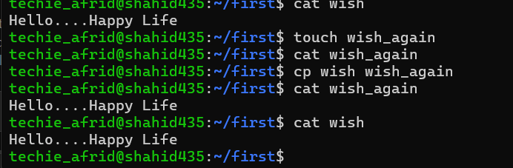
content in one file to another file in the same directory’s directory
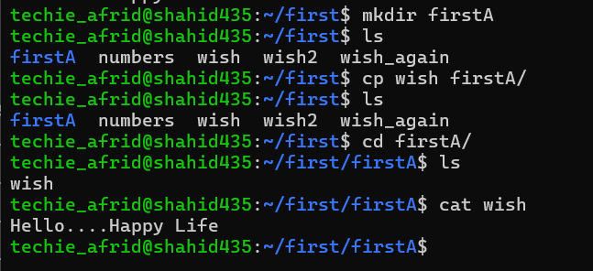

- Move a file to another location.
Objective:
To move a file from one location to another within the Linux file system.
Purpose:
The purpose of moving a file is to relocate files between directories, organize data efficiently, and manage the file system structure.
Implementation:
A file was moved to another location using the mv command followed by the source file name and the destination path. The file location was then verified to ensure that the move operation was completed successfully.
Conclusion:
The file was successfully moved to the specified location, improving file organization and making data management more efficient.
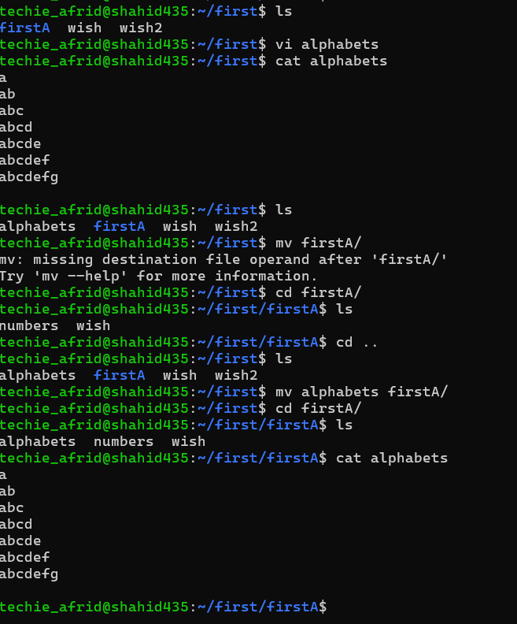

- Rename a file.
Objective:
To change the name of an existing file in the Linux file system.
Purpose:
The purpose of renaming a file is to give it a more meaningful name, improve file organization, and make it easier to identify and manage.
Implementation:
The file was renamed using the mv command by specifying the existing file name and the new file name. The change was then verified to ensure that the file had been successfully renamed.
Conclusion:
The file was successfully renamed, making it easier to identify and manage within the directory structure.
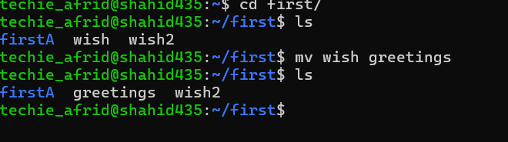

- Delete a file.
To remove an unwanted file from the Linux file system.
Purpose:
The purpose of deleting a file is to free up storage space, remove unnecessary data, and maintain an organized file system.
Implementation:
The unwanted file was deleted using the rm command followed by the file name. The directory contents were checked afterward to confirm that the file had been successfully removed.
Conclusion:
The file was successfully deleted from the system, helping to maintain a clean and organized directory structure.
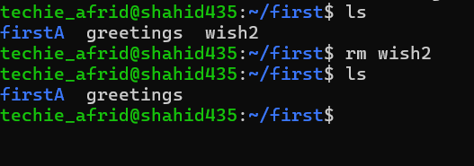

- Grant or revoke permissions on a file or directory.
Objective:
To modify the access permissions of a file or directory to control user access and security.
Purpose:
The purpose of granting or revoking permissions is to manage who can read, write, or execute files and directories, ensuring proper security and access control.
Implementation:
File or directory permissions were modified using the chmod command. Required permissions were granted or removed by adjusting the access levels for the owner, group, and other users. The updated permissions were verified to ensure that the changes were applied successfully.
Conclusion:
The permissions of the file or directory were successfully modified, providing controlled access and improving the security and management of system resources.
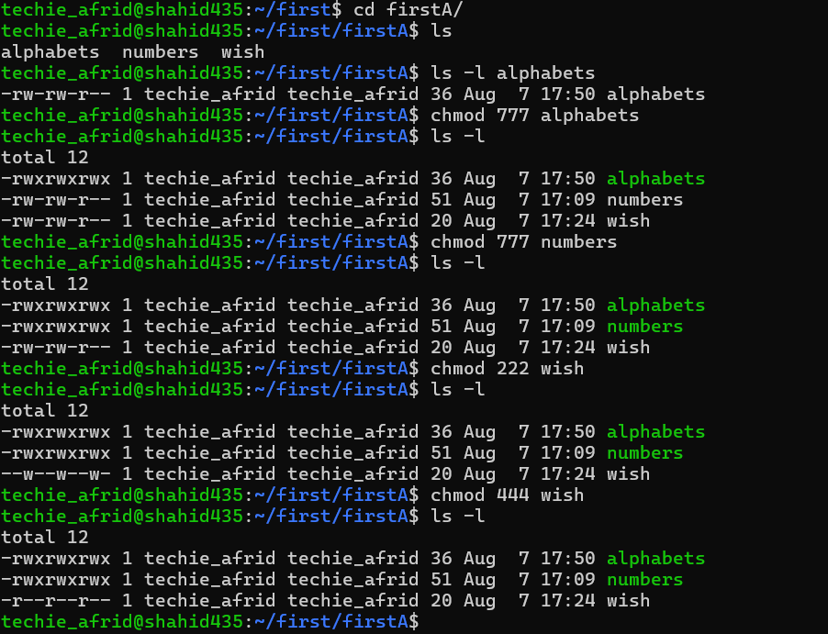

- View the current date and time.
Objective:
To view the current date and time of the Linux system.
Purpose:
The purpose of checking the current date and time is to monitor system time, verify timestamps, and assist in scheduling and managing system activities.
Implementation:
The current date and time were displayed using the date command. The output was checked to view the system's current date, time, and related information.
Conclusion:
The current date and time were successfully viewed, helping the user monitor and manage time-related system operations effectively.
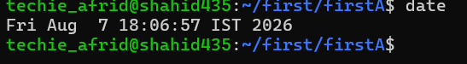

- Check the system uptime.
Objective:
To check the amount of time the Linux system has been running since the last boot.
Purpose:
The purpose of checking system uptime is to monitor system availability, identify recent restarts, and analyze system performance and stability.
Implementation:
The system uptime was checked using the uptime command. The output was reviewed to view the system running time, number of logged-in users, and system load information.
Conclusion:
The system uptime was successfully checked, providing information about how long the system has been active and helping in monitoring system reliability.

- View the running processes.
Objective:
To view the currently running processes in the Linux system.
Purpose:
The purpose of viewing running processes is to monitor system activity, identify active programs, and manage system resources effectively.
Implementation:
The running processes were displayed using the ps command. The process information was analyzed to view active tasks, process IDs, and resource usage details.
Conclusion:
The running processes were successfully viewed, allowing the user to monitor system activities and manage processes efficiently.
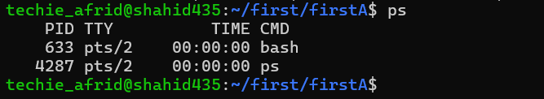

- Kill a running process.
Objective:
To terminate a running process in the Linux system.
Purpose:
The purpose of killing a running process is to stop unwanted, unresponsive, or unnecessary programs and free system resources.
Implementation:
A running process was terminated using the kill command followed by the process ID (PID). The process status was checked afterward to confirm that the process had been successfully stopped.
Conclusion:
The selected running process was successfully terminated, helping to improve system performance and manage active system tasks effectively.
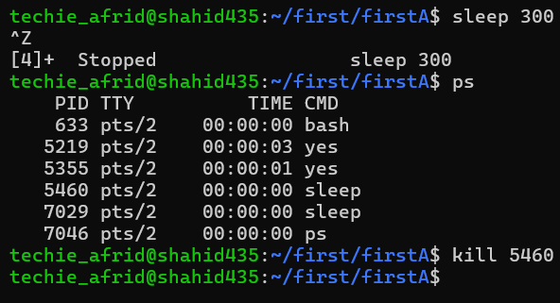

- Install a package using the package manager (e.g., apt or yum).
Objective:
To install a package using the package manager in the Linux system.
Purpose:
The purpose of installing a package is to add required software to the Linux system and manage it efficiently using the package manager.
Implementation:
The tree package was installed using the apt package manager with the following commands:
sudo apt update
sudo apt install tree
tree --version
Conclusion:
The tree package was successfully installed and verified, demonstrating how the package manager can be used to install and manage software packages in Linux.
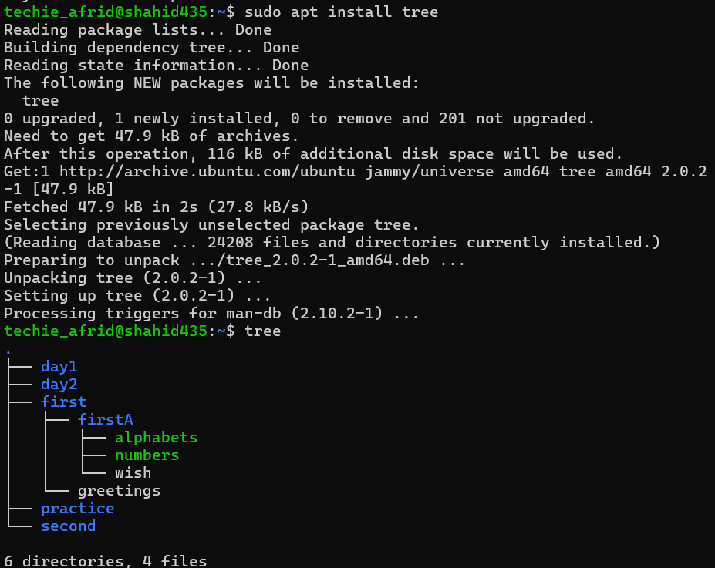
- Update the system packages.
Objective:
To update the system packages in the Linux system.
Purpose:
The purpose of updating system packages is to install the latest available updates, improve system security, and fix bugs and issues.
Implementation:
The system packages were updated using the apt package manager with the following command:
sudo apt update
sudo apt upgrade
Conclusion:
The system packages were successfully updated, ensuring that the Linux system has the latest available software updates and security improvements.
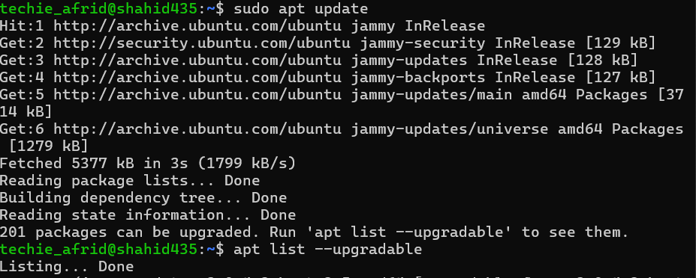

- Create a symbolic link.
Objective:
To create a symbolic link in the Linux system.
Purpose:
The purpose of creating a symbolic link is to provide an easy way to access a file or directory from another location.
Implementation:
A symbolic link was created using the ln -s command with the following commands:
touch original.txt
ln -s original.txt link.txt
ls -l
Conclusion:
The symbolic link was successfully created, demonstrating how ln -s can be used to create links to files or directories in Linux.
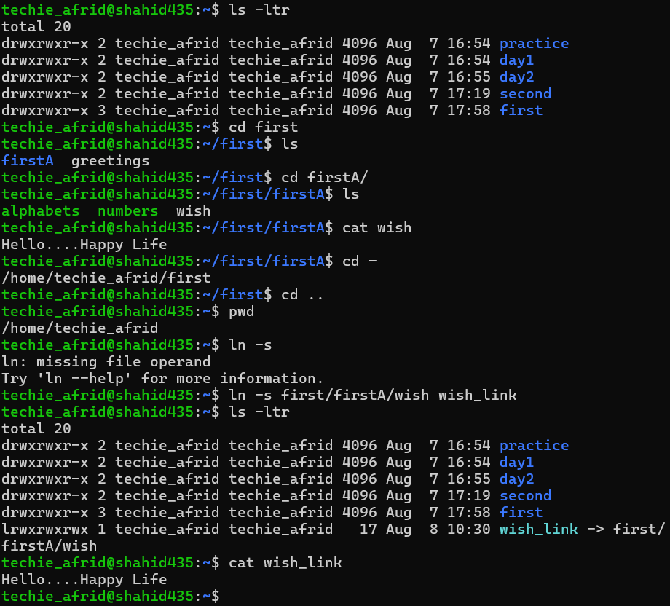
- Search for files using the find command.
Objective:
To search for files in the Linux system using the find command.
Purpose:
The purpose of using the find command is to locate files and directories based on their name, type, location, or other specified criteria.
Implementation:
A file was searched using the find command with the following commands:
touch sample.txt
find . -name "sample.txt"
Conclusion:
The required file was successfully located using the find command, demonstrating how files can be searched efficiently in the Linux system.
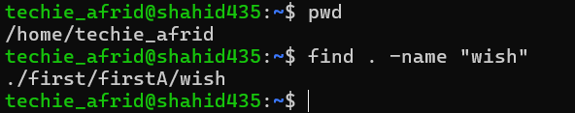

- Compress and decompress files using tar.
Objective:
To compress and decompress files and directories using the tar command in the Linux system.
Purpose:
The purpose of using the tar command is to combine multiple files or directories into a single archive and compress or extract them easily.
Implementation:
Files were compressed and decompressed using the tar command with the following commands:
mkdir project
touch project/file1.txt project/file2.txt
tar -czvf project.tar.gz project/
tar -xzvf project.tar.gz
tar -tvf project.tar.gz
Conclusion:
The files were successfully compressed and decompressed using the tar command, demonstrating how tar can be used to create, extract, and manage archived files and directories in Linux.

- Monitor system resources with top or htop.
Objective:
To monitor system resources such as CPU usage, memory usage, and running processes in the Linux system.
Purpose:
The purpose of monitoring system resources is to check system performance and identify processes consuming excessive CPU or memory.
Implementation:
System resources were monitored using the top and htop commands:
top
htop
Conclusion:
The system resources were successfully monitored using top or htop, demonstrating how to view running processes and CPU and memory utilization in Linux.

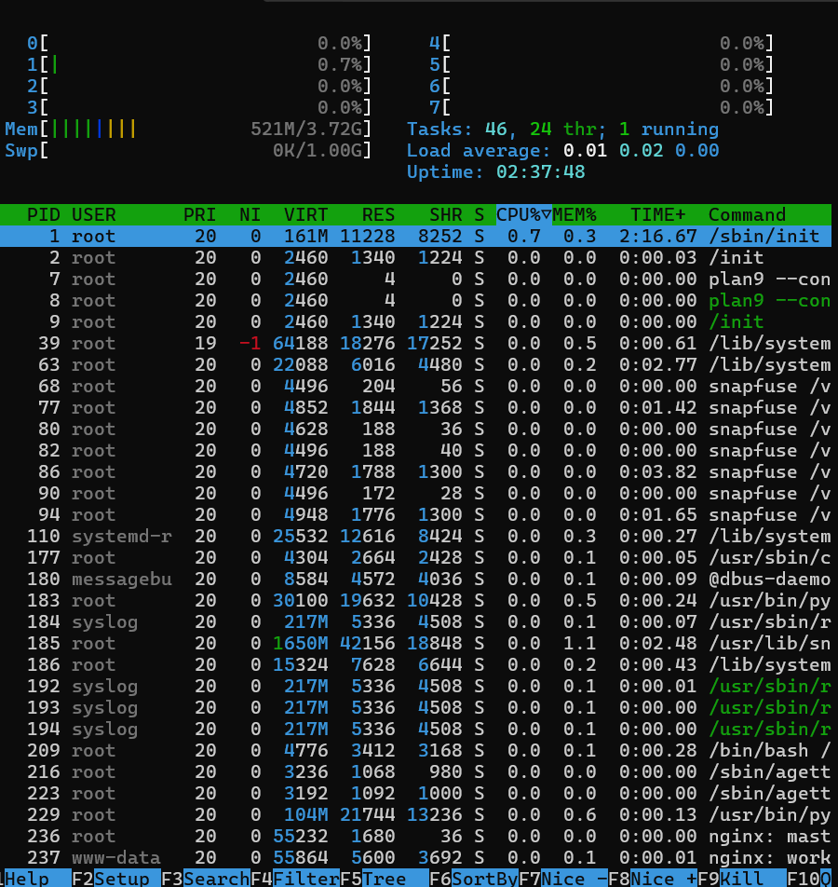
- Create and manage user groups.
Objective:
To create and manage user groups in the Linux system.
Purpose:
The purpose of creating user groups is to organize users and manage their permissions and access to system resources efficiently.
Implementation:
A group was created and a user was added to the group using the following commands:
sudo groupadd developers
sudo usermod -aG developers username

groups username
Conclusion:
The user group was successfully created and managed, demonstrating how Linux groups can be used to organize users and control access permissions.
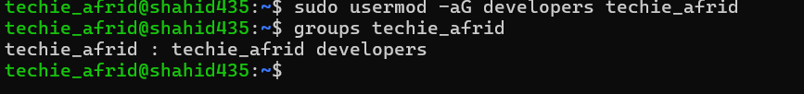

- Set up SSH password less authentication.
Objective:
To configure passwordless SSH authentication between two Linux systems.
Purpose:
The purpose of passwordless SSH authentication is to allow secure remote login without entering a password each time.
Implementation:
An SSH key pair was generated and copied to the remote system using the following commands:
ssh-keygen
ssh-copy-id username@remote_ip
ssh username@remote_ip
Conclusion:
Passwordless SSH authentication was successfully configured, demonstrating secure login to a remote Linux system using SSH keys.
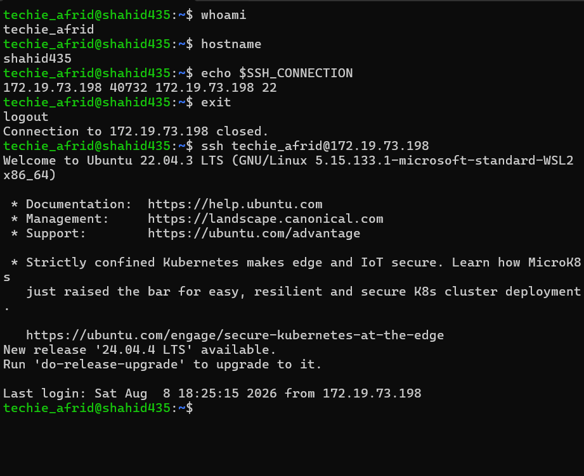

- Monitor log files using tail or grep.
Objective:
To monitor and search log files using the tail and grep commands.
Purpose:
The purpose of monitoring log files is to observe system activities and identify errors, warnings, or specific events.
Implementation:
A log file was monitored and searched using the following commands:
tail -f /var/log/syslog
grep "error" /var/log/syslog
Conclusion:
The log files were successfully monitored and searched using tail and grep, demonstrating how Linux logs can be examined for specific events and errors.
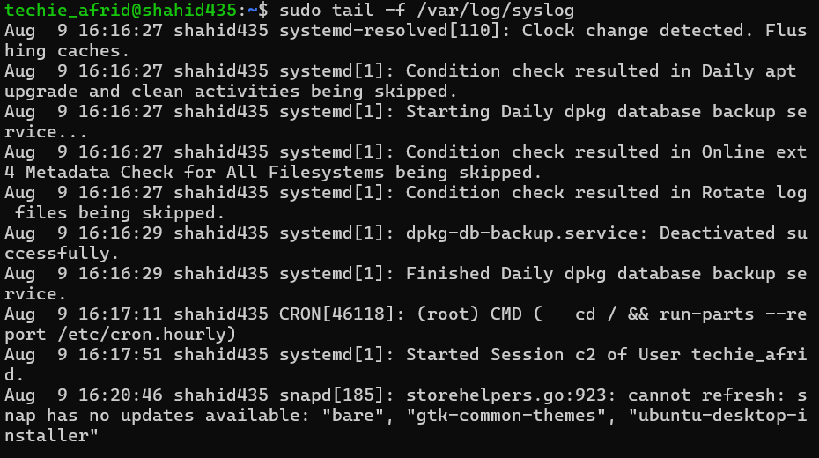
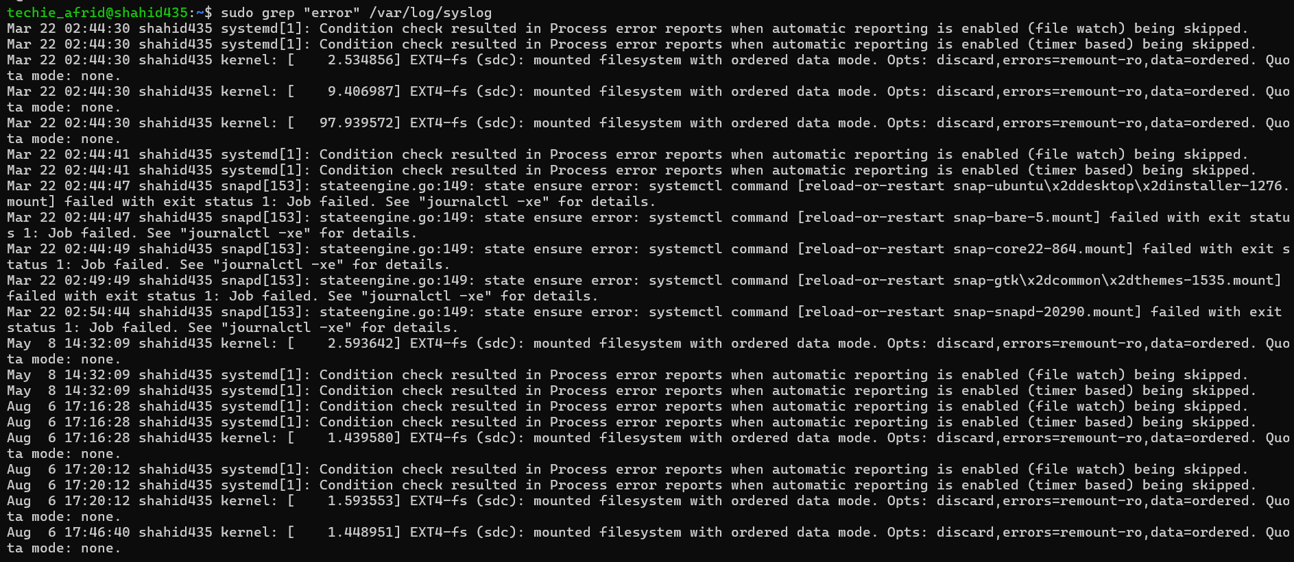
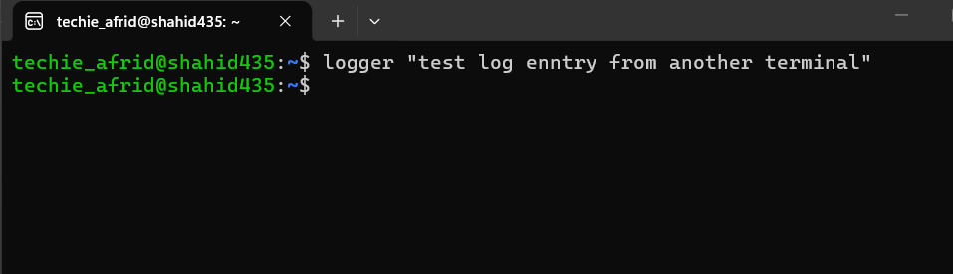
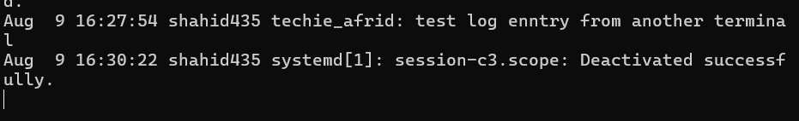

- Set up a web server (e.g., Apache or Nginx).
Objective:
To install and configure an Apache web server in the Linux system.
Purpose:
The purpose of setting up a web server is to host and serve web pages over a network.
Implementation:
Apache was installed and started using the following commands:
sudo apt update
sudo apt install apache2
sudo systemctl start apache2
sudo systemctl enable apache2
sudo systemctl status apache2
Conclusion:
The Apache web server was successfully installed, configured, and started, demonstrating how Linux can be used to host web applications and web pages.
Nginx is already intelled so I installed apache and when I check status of apache2 it shows failed because ,nginx using the port 80.
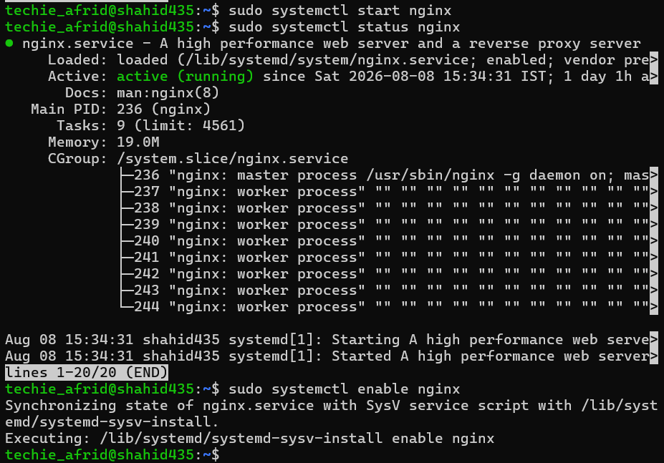
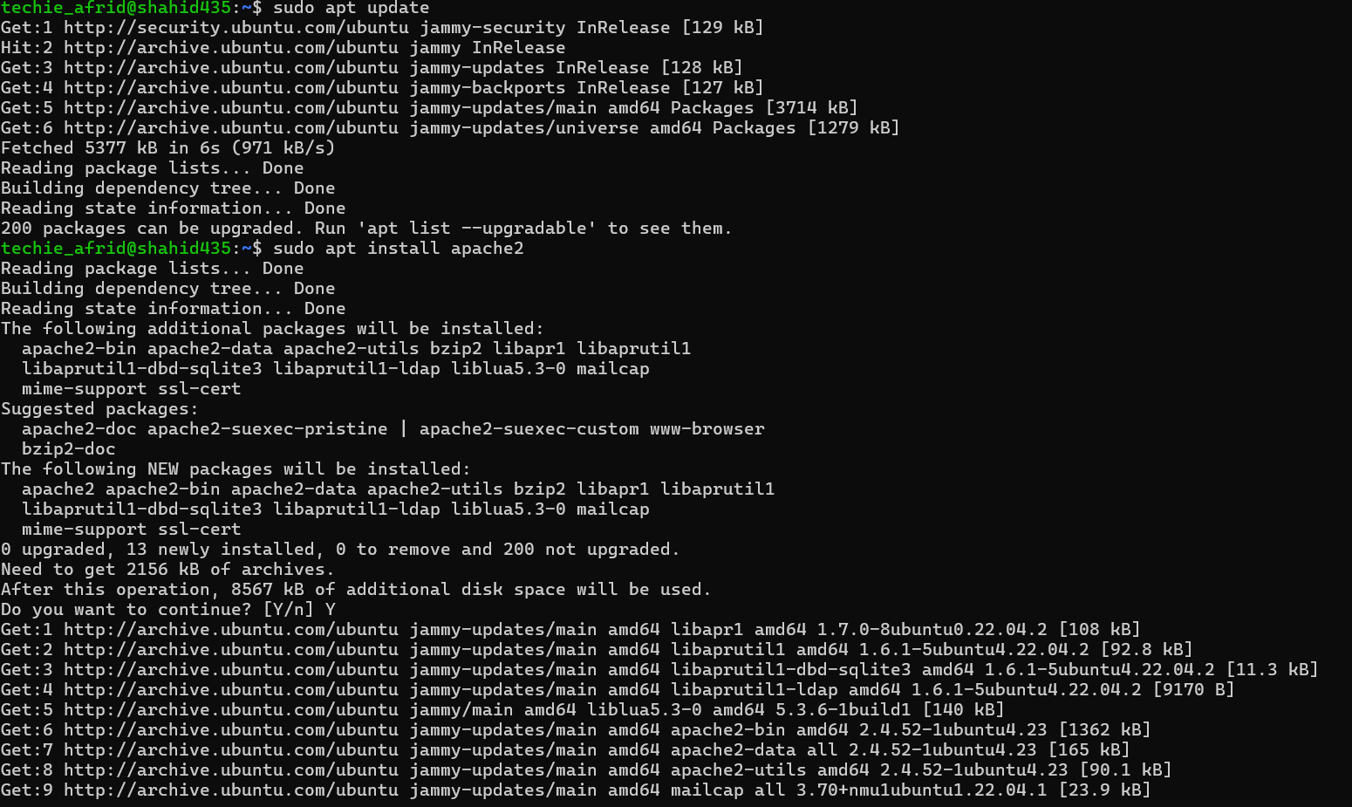

- Configure and secure a MySQL Database.
Objective:
To install, configure, and secure a MySQL database server in Linux.
Purpose:
The purpose of configuring MySQL is to provide a secure database environment for storing and managing data.
Implementation:
MySQL was installed and secured using the following commands:
sudo apt update
sudo apt install mysql-server
sudo systemctl start mysql
sudo systemctl enable mysql
sudo mysql_secure_installation
Conclusion:
MySQL was successfully installed and secured, demonstrating how to configure a database server and improve its basic security in Linux.
Apt update
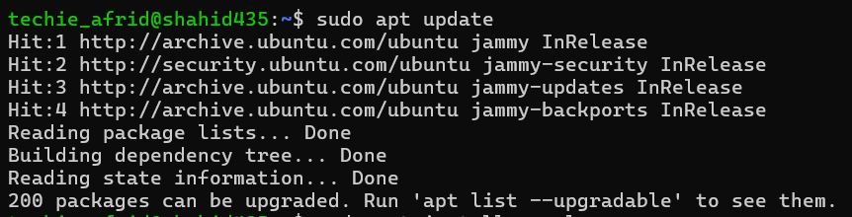
Installation of Mysql-server
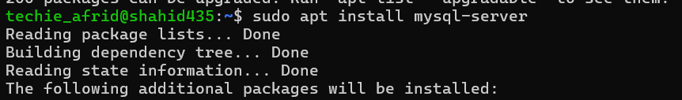
Status
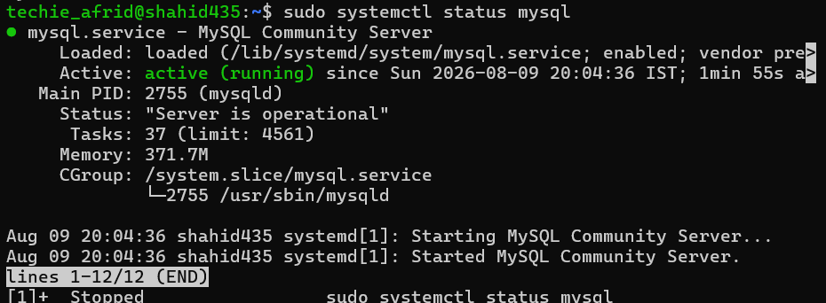
secure
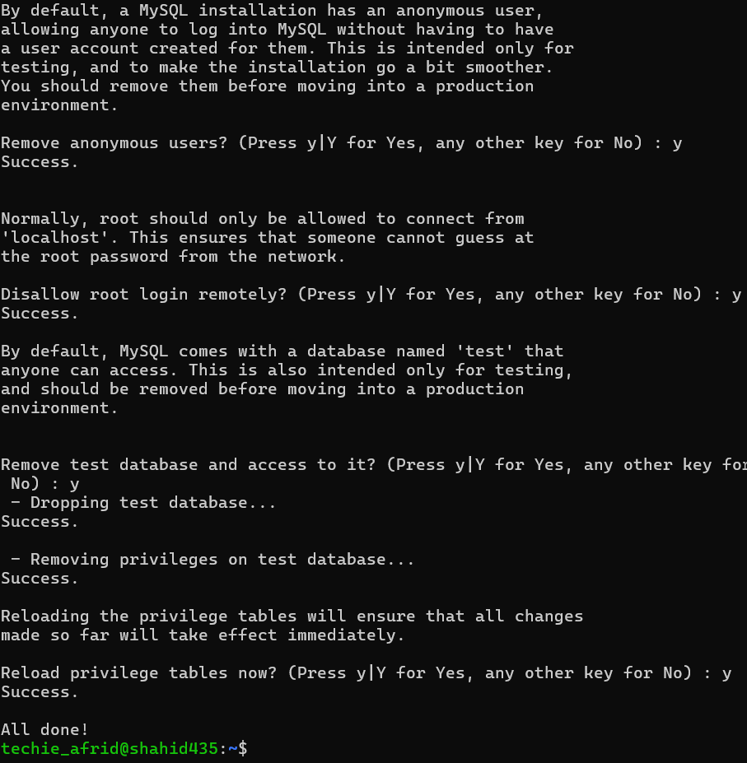
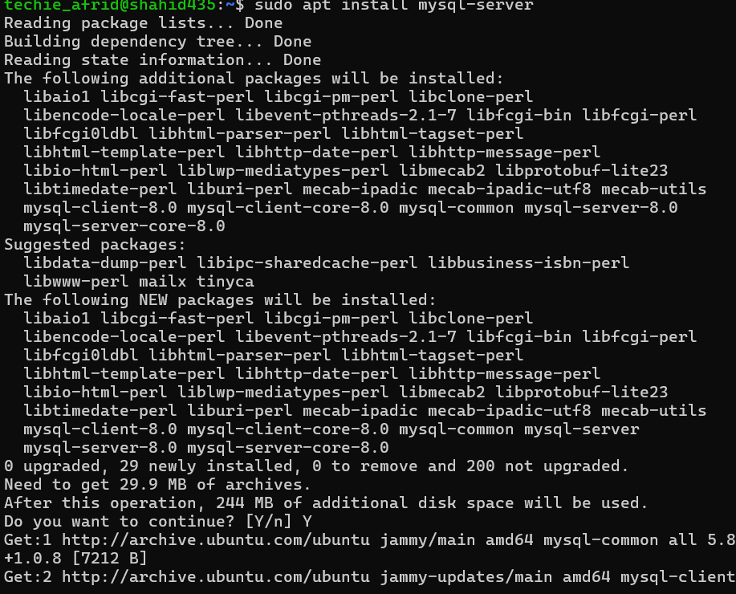

- Set up a Application Server (e.g.,Apache Tomcat)
Objective:
To install and configure Apache Tomcat as an application server in Linux.
Purpose:
The purpose of setting up Apache Tomcat is to provide an environment for deploying and running Java-based web applications.
Implementation:
Apache Tomcat was downloaded, extracted, and started using the following commands:
wget https://dlcdn.apache.org/tomcat/tomcat-10/v10.1.XX/bin/apache-tomcat-10.1.XX.tar.gz
tar -xzf apache-tomcat-10.1.XX.tar.gz
cd apache-tomcat-10.1.XX/bin
./startup.sh
./shutdown.sh
Conclusion:
Apache Tomcat was successfully installed and configured, demonstrating how it can be used as an application server for Java web applications.
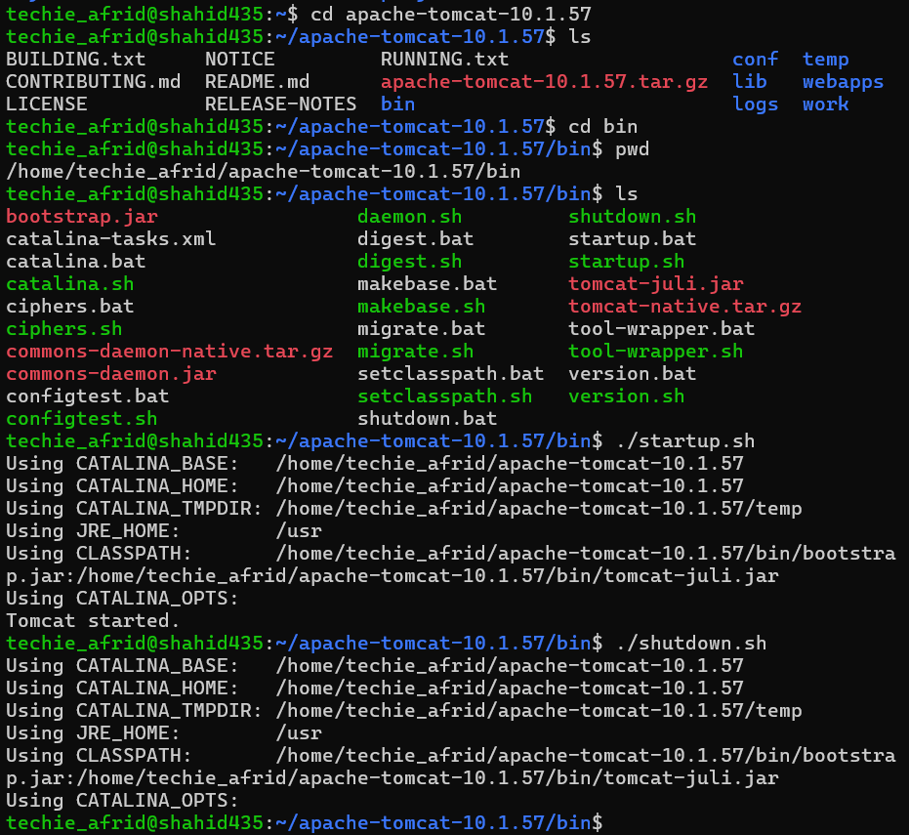

- create a service file for Apache Tomcat.(Should execute by using systemtctl command)
Objective:
To create a systemd service file for Apache Tomcat and manage it using systemctl.
Purpose:
To manage Tomcat as a Linux service and easily start, stop, restart, and check its status.
Implementation:
Created a tomcat.service file in /etc/systemd/system/ and used commands such as:
sudo systemctl daemon-reload
sudo systemctl start tomcat
sudo systemctl status tomcat
sudo systemctl enable tomcat
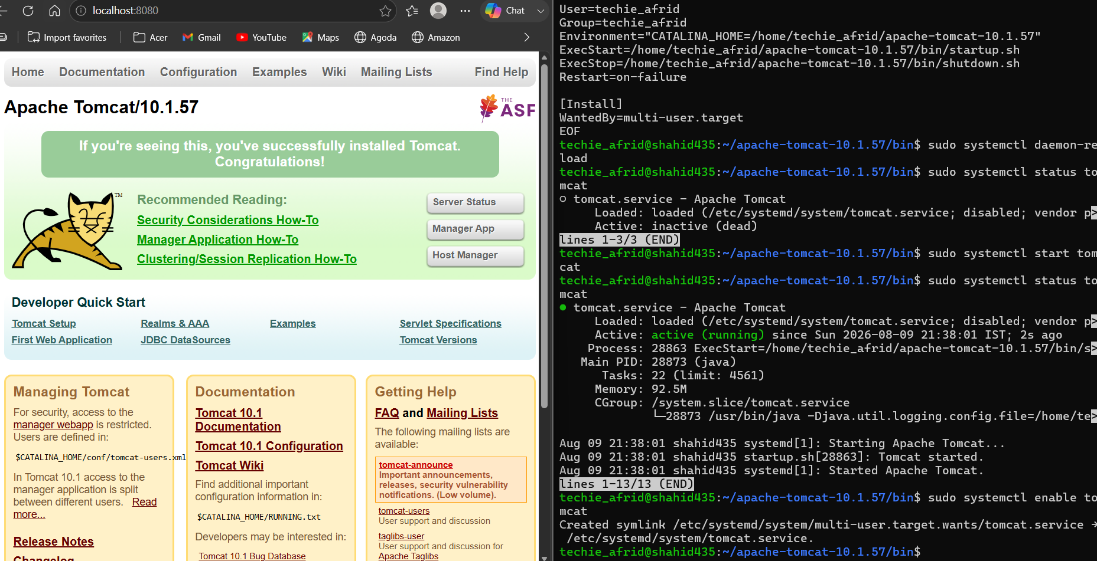

Conclusion:
Apache Tomcat was successfully configured as a systemd service and managed using systemctl. Tomcat was started successfully and verified through the browser using localhost:8080.

- Print specific columns from a delimited file.
Objective:
To print specific columns from a delimited file using the awk command.
Purpose:
The purpose is to extract and display selected fields from structured or delimited data files.
Implementation:
A CSV file was used and specific columns were printed using:
awk -F',' '{print $1, $3}' data.csv
Conclusion:
The required columns were successfully extracted from the delimited file using awk.

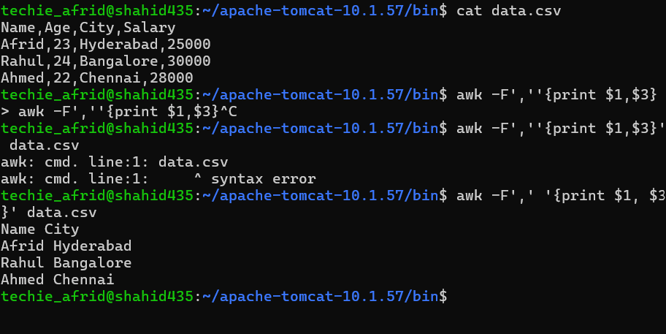
- Filter and print lines based on a specific pattern or condition.
Objective:
To filter and print lines from a file based on a specific pattern or condition.
Purpose:
The purpose is to identify and display only the lines that satisfy a given condition.
Implementation:
Lines containing a specific pattern were printed using:
awk '/Linux/ {print}' file.txt
Conclusion:
The required lines were successfully filtered and displayed based on the specified pattern using awk.
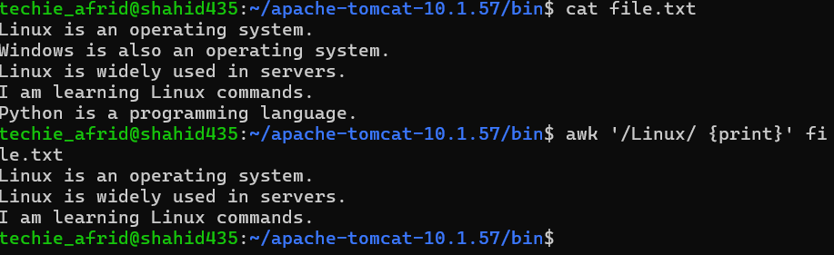

- Calculate and print the average, sum, or other statistics of a column.
Objective:
To calculate the sum and average of a column in a file using awk.
Purpose:
The purpose is to perform mathematical calculations on numerical data stored in a file.
Implementation:
The sum and average of the second column were calculated using:
awk '{sum += $2} END {print "Sum =", sum, "Average =", sum/NR}' data.txt
Conclusion:
The sum and average of the specified column were successfully calculated using awk.
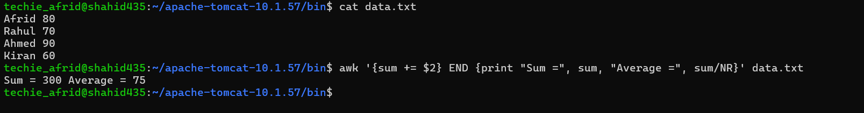

- Perform string manipulation, such as extracting substrings or changing case.
Objective:
To perform string manipulation such as extracting substrings and changing case using awk.
Purpose:
The purpose is to modify and process text data according to specific requirements.
Implementation:
A substring was extracted and text was converted to uppercase using:
awk '{print substr($1,1,5)}' file.txt
awk '{print toupper($1)}' file.txt
Conclusion:
String manipulation was successfully performed using awk, demonstrating substring extraction and case conversion.
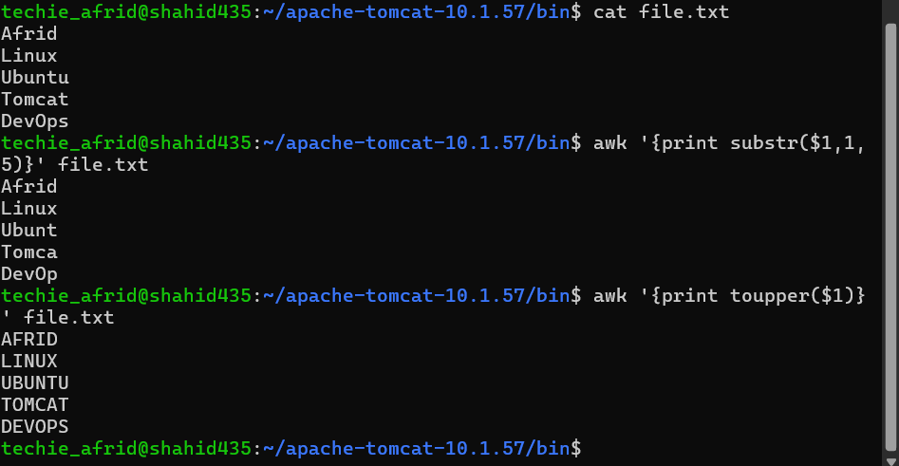

- Count the occurrences of a specific pattern in a file.
Objective:
To count the occurrences of a specific pattern in a file.
Purpose:
The purpose is to determine how many times a particular word or pattern appears in a file.
Implementation:
The occurrences of a pattern were counted using:
grep -o "Linux" file.txt | wc -l
Conclusion:
The number of occurrences of the specified pattern was successfully counted using grep and wc. 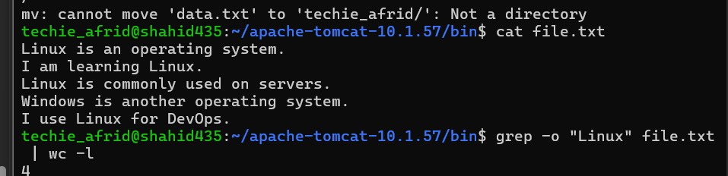

- Sort lines based on a specific field or column.
Objective:
To sort lines in a file based on a specific field or column.
Purpose:
The purpose is to arrange data in ascending or descending order according to a selected field.
Implementation:
The file was sorted based on the second column using:
sort -k2 file.txt
For numerical sorting:
sort -k2 -n file.txt
Conclusion:
The lines were successfully sorted based on the specified column using the sort command.
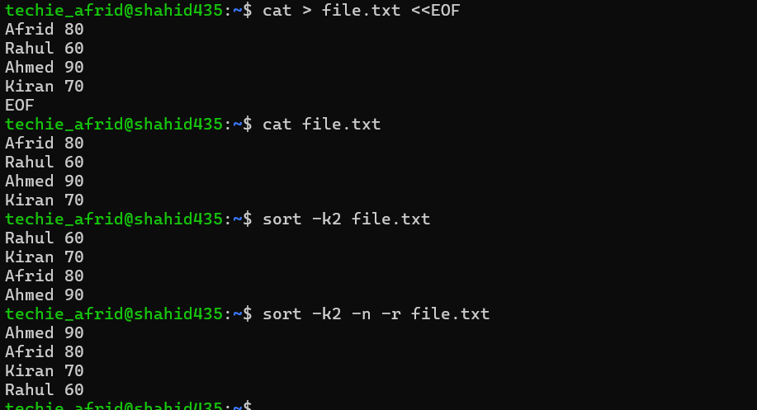

- Merge multiple files based on a common field or column.
Objective:
To merge two files based on a common field or column.
Purpose:
The purpose is to combine related information from multiple files using a common key.
Implementation:
Two sorted files were merged using the join command:
sort -k1 file1.txt > file1_sorted.txt
sort -k1 file2.txt > file2_sorted.txt
join -1 1 -2 1 file1_sorted.txt file2_sorted.txt
Conclusion:
The files were successfully merged based on a common field using the join command.
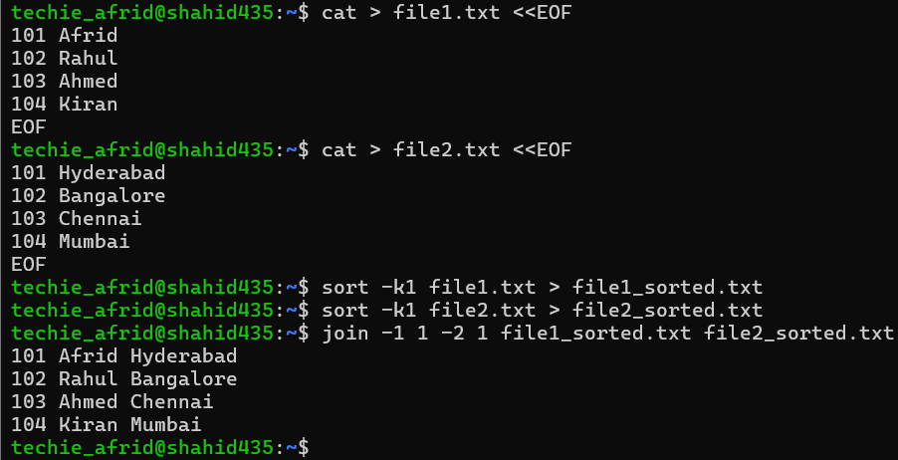
- Substitute text in a file using search and replace.
Objective:
To search for and replace specific text in a file using the sed command.
Purpose:
The purpose is to modify text efficiently without manually editing the entire file.
Implementation:
The word old was replaced with new using:
sed -i 's/old/new/g' file.txt
Conclusion:
The specified text was successfully replaced using sed, demonstrating search-and-replace functionality in Linux.

- Delete specific lines based on a pattern or line number.
Objective:
To delete specific lines from a file based on a pattern or line number.
Purpose:
The purpose is to remove unwanted lines from a file efficiently using sed.
Implementation:
A specific line and lines containing a pattern were deleted using:
sed -i '3d' file.txt
sed -i '/error/d' file.txt
Conclusion:
The specified lines were successfully deleted from the file using sed.

- Append or insert text before or after a specific pattern or line.
Objective:
To insert or append text before or after a specific pattern or line in a file.
Purpose:
The purpose is to add required information at a specific location within a file.
Implementation:
Text was inserted after a matching pattern using:
sed -i '/Linux/a This is a new line' file.txt
Text was inserted before a matching pattern using:
sed -i '/Linux/i This line comes before' file.txt
Conclusion:
Text was successfully inserted before and after a specified pattern using the sed command.
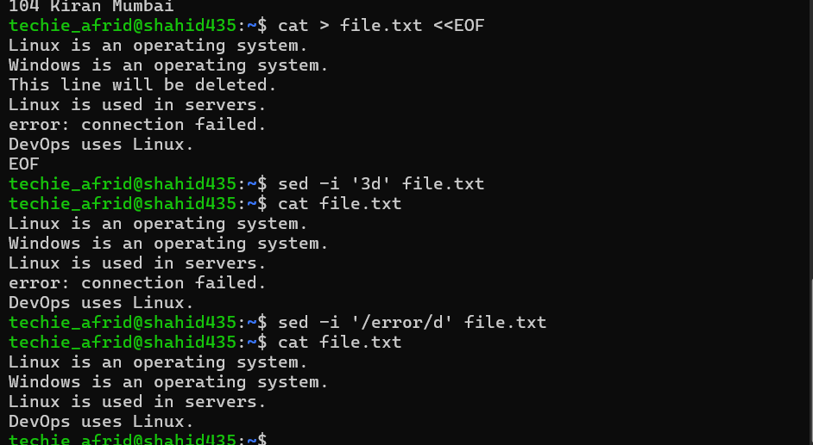
- Print only specific lines from a file.
Objective:
To print only specific lines from a file using the sed command.
Purpose:
The purpose is to display only the required portion of a file without displaying its complete contents.
Implementation:
Specific lines were printed using:
sed -n '2,5p' file.txt
Conclusion:
The specified lines were successfully displayed using sed.
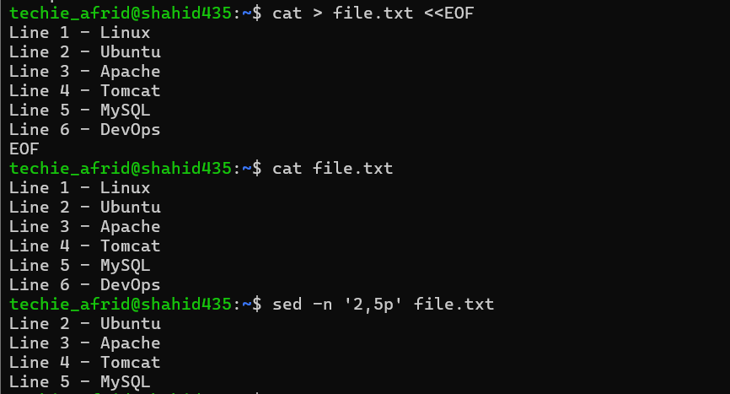
- Copy file from linux to windows machine
Objective:
To copy a file from a Linux machine to a Windows machine over a network.
Purpose:
The purpose is to transfer files securely between Linux and Windows systems using SSH and SCP.
Implementation:
The file was copied from Linux to the Windows machine using:
scp file.txt windows_username@windows_ip:/path/to/destination/
For example:
scp report.txt user@192.168.1.10:/Users/user/Desktop/
Conclusion:
The file was successfully transferred from the Linux machine to the Windows machine using scp, demonstrating secure file transfer over a network.
NOTE:
Facing ssh installation issues so I used scp for linux to linux using two different terminals and users……
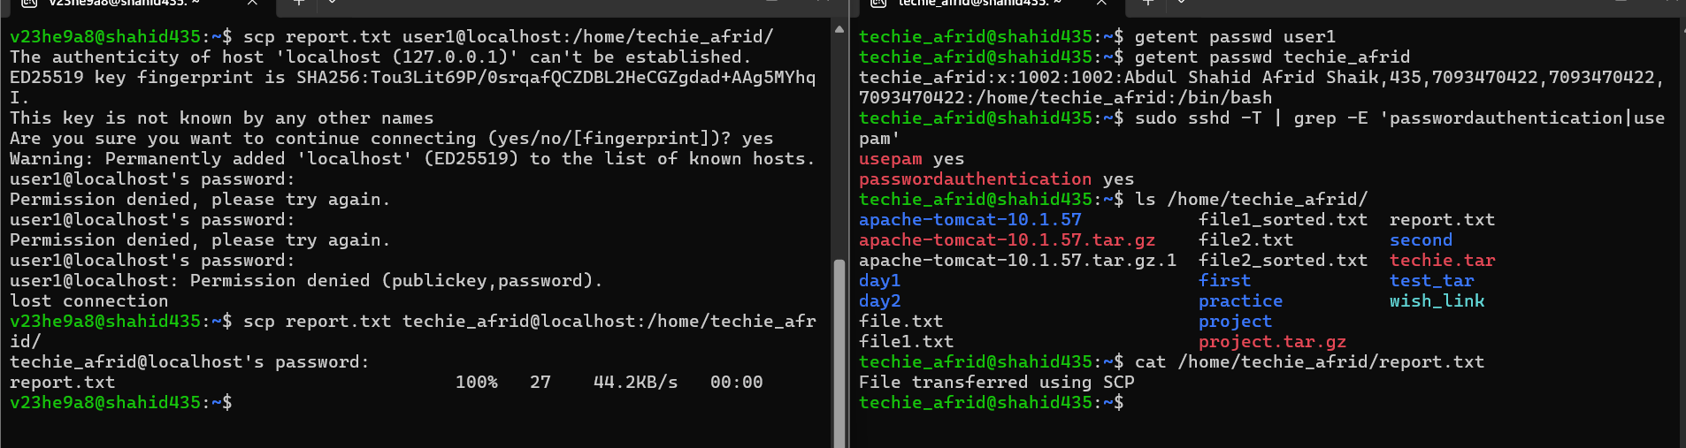
Facing ssh installation issues so I used scp for linux to linux using two different terminals and users……
- 5 use cases for AWK and 5 use cases for sed
Objective:
To understand and demonstrate five common use cases of the awk and sed commands in Linux.
Purpose:
The purpose is to learn how awk can be used for text processing and data analysis, and how sed can be used for editing and transforming text.
Implementation:
Five use cases of awk:
- Print specific columns
awk '{print $1, $3}' file.txt
- Filter lines based on a pattern
awk '/Linux/ {print}' file.txt
- Calculate sum and average
awk '{sum += $2} END {print sum, sum/NR}' file.txt
- Count lines matching a condition
awk '$2 > 50 {count++} END {print count}' file.txt
- Change text to uppercase
awk '{print toupper($1)}' file.txt

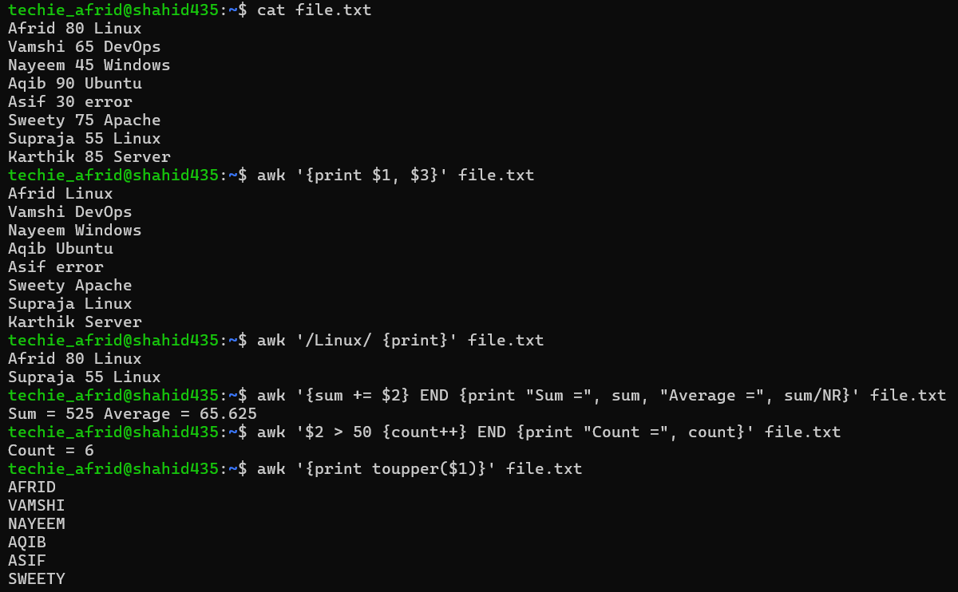

Five use cases of sed:
- Search and replace text
sed 's/old/new/g' file.txt
- Delete a specific line
sed '3d' file.txt
- Delete lines matching a pattern
sed '/error/d' file.txt
- Print specific lines
sed -n '2,5p' file.txt
- Insert text after a pattern
sed '/Linux/a New line' file.txt
Conclusion:
The awk and sed commands were successfully used for different text-processing operations. awk is useful for field processing, filtering, and calculations, while sed is useful for searching, replacing, deleting, and modifying text.
